
Department of Computer Science & Engineering

Program: Bachelor of Engineering in Computer Science & Engineering

A Project Report on
POS SYSTEM

Submitted in partial fulfillment of the requirements for the course

CS64: MINI PROJECT

By

DEEPTHI S SHETTY 1MS17CS027
K V SANDEEP 1MS17CS045
MANOJ D 1MS17CS059
P DHANUSHA 1MS17CS078

Under the guidance of

Dr. JAYALAKSHMI D.S
Associate Professor

M S RAMAIAH INSTITUTE OF TECHNOLOGY
(Autonomous Institute, Affiliated to VTU)
BANGALORE-560054
www.msrit.edu
2020

M. S. RAMAIAH INSTITUTE OF TECHNOLOGY, BANGALORE – 560 054
(Autonomous Institute, Affiliated to VTU)

DEPARTMENT OF COMPUTER SCIENCE AND ENGINEERING

INCLUDEPICTURE "https://encrypted-tbn2.gstatic.com/images?q=tbn:ANd9GcRNrUtA8XrZD_gNisUsJL4fDdBQEQj4cEp0kCk53lBI_n46xzAFM7kn82Y" \* MERGEFORMATINET INCLUDEPICTURE "https://encrypted-tbn2.gstatic.com/images?q=tbn:ANd9GcRNrUtA8XrZD_gNisUsJL4fDdBQEQj4cEp0kCk53lBI_n46xzAFM7kn82Y" \* MERGEFORMATINET INCLUDEPICTURE "https://encrypted-tbn2.gstatic.com/images?q=tbn:ANd9GcRNrUtA8XrZD_gNisUsJL4fDdBQEQj4cEp0kCk53lBI_n46xzAFM7kn82Y" \* MERGEFORMATINET 

CERTIFICATE

Certified that the project work titled “POS System” carried out by DEEPTHI S SHETTY-1MS17CS027, K V SANDEEP -1MS17CS045, MANOJ D -1MS17CS059,
P DHANUSHA -1MS17CS078 are bonafide students of M. S. Ramaiah Institute of Technology, Bengaluru, in partial fulfillment of the course Mini Project CS64 during the term Jan-May 2020. The project report has been approved as it satisfies the academic requirements for the aforesaid course. To the best of our understanding, the work submitted in this report is the original work of students.

Project Guide Head of the Department

Dr. JAYALAKSHMI D. S Dr. ANITA KANAVALLI

External Examiners

Name of the Examiners: Signature with Date

1.
2.

DECLARATION

We, hereby, declare that the entire work embodied in this mini project report has been carried out by us at M. S. Ramaiah Institute of Technology, Bengaluru, under the supervision of Dr. Jayalakshmi D. S, Associate Professor, Department of CSE. This report has not been submitted in part or full for the award of any diploma or degree of this or to any other university.

Signature Signature
DEEPTHI S SHETTY K V SANDEEP
1MS17CS027 1MS17CS045

Signature Signature
MANOJ D P DHANUSHA
1MS17CS059 1MS17CS078

ACKNOWLEDGEMENT

We take this opportunity to express our gratitude to the people who have been instrumental in the successful completion of this project. We would like to express our profound gratitude to the Management and Dr. N.V.R Naidu Principal, M.S.R.I.T, Bengaluru for providing us with the opportunity to explore our potential.

We extend our heartfelt gratitude to our beloved Dr. Anita Kanavalli, HOD, Computer Science and Engineering, for constant support and guidance.

We whole-heartedly thank our project guide Dr. Jayalakshmi D. S, for providing us with the confidence and strength to overcome every obstacle at each step of the project and inspiring us to the best of our potential. We also thank him/her for her constant guidance, direction and insight during the project.

This work would not have been possible without the guidance and help of several individuals who in one way or another contributed their valuable assistance in preparation and completion of this study.

Finally, we would like to express sincere gratitude to all the teaching and non-teaching faculty of CSE Department, our beloved parents, seniors and my dear friends for their constant support during the course of work.

STUDENT NAMES:

DEEPTHI S SHETTY K V SANDEEP

MANOJ D P DHANUSHA

Abstract

The main purpose of the project is to develop an end to end interface between the client and the Computer Services company. The Company handles all kinds of computer services along with providing any devices necessary for the Clients to servicing their products. The application is the need of the hour in order to upgrade from manual records, employee management and performance analysis of its Employees. Considering the future insight to expand business this helps them in better to serve to its clients.
Employees are the backbone of any company therefore their management plays a major role in deciding the success of an organization. Employees Management makes it easy for the employer to keep track of all records. This software allows the administrator to edit employees, add new employees, terminate employees. Most of all, the employer can change assign tasks to employees, know feedback from employees regarding their task at hand and deal with same, feedback from clients for the service satisfaction and assess employees progress in order to keep track of employee performance
A flexible and easy to use Employee Management software solution for small and medium sized companies provides modules for personnel information management thereby organization and companies are able to manage the crucial organization asset people. The combination of these modules into one application assures the perfect platform for re-engineering and aligning Human Resource processes along with the organizational goals. This system brings about an easy way of maintaining the details of employees.
It is simple to understand and can be used by anyone who is not even familiar with simple employee’s system. It is user friendly and just asks the user to follow step by step operations by giving easy to follow options. It is fast and can perform many operations for a company. The goal of this project is to design and develop an employee-client management system to fill existing gaps of manual work by employer.

TABLE OF CONTENTS

Chapter No. Title Page No.
Abstract v
List of Figures viii
List of Tables ix
1 INTRODUCTION 10
  - General Introduction 10
  - Problem Statement 10
  - Objectives of the project 10
  - Project deliverables 11
  - Current Scope 11
  - Future Scope 11
- PROJECT ORGANIZATION 12
  - Software Process Models 12
  - Roles and Responsibilities 12
- PROJECT MANAGEMENT PLAN 13
  - Schedule of the Project (Represent it using Gantt Chart) 13
  - Risk Identification 13
- SOFTWARE REQUIREMENT SPECIFICATIONS 14
4.1 Purpose 14
4.2 Project Scope 14
4.3 Overall description 14
4.3.1 Product perspectives 14
4.3.2 Product features 14
4.3.3 Operating environment 14
4.4 External Interface Requirements 15
4.4.1 User Interfaces 15
4.4.2 Hardware Interfaces 15
4.4.3 Software Interfaces 15
4.4.4 Communication Interfaces 15
4.5 System Features 15
4.5.1 Functional requirements 16
4.5.2 Nonfunctional requirements 16
4.5.3 Use case description 17
4.5.4 Use case diagram 20

5 Design 21
5.1 Introduction 21
5.2 Architecture Design as per the selected architectural
style ( Structure diagram (structured approach)) 20
5.3 Low Level Design (Flowchart (structured approach) or
Sequence and state diagram(Object oriented approach)) 23
5.4 Conclusion 26

6 IMPLEMENTATIONS 27
6.1 Technology Introduction 27
6.2 Explanation of Algorithm and how it is been implemented 28
6.3 Information about the implementation of Modules 29
7 TESTING 30
  - Introduction 30
  - Test cases 30
8 RESULTS & PERFORMANCE ANALYSIS 37
8.1 Result Snapshots 37
9 CONCLUSION & SCOPE FOR FUTURE WORK 47
9.1 Limitation of this Work 47
9.2 Directions for the Future works 47

LIST OF FIGURES

Figure No. Title Page No.

3.1 Gantt Chart 13
4.5 Use Case Diagram 20
5.2.1 Structure Diagram of User 21
5.2.2 Structure Diagram of Employee and Admin 22
5.3.1 Sequence Diagram for client services 23
5.3.2 Sequence Diagram for Admin operation 24
5.3.3 Sequence Diagram of Employee operation 25
8.1.1 Homepage 34
8.1.2 User (Login as u ser) 34
8.1.3 Reporting an issue 35
8.1.4 Conformation Token 35
8.1.5 Message after submission of complaint 36
8.1.6 New Service Request 36
8.1.7 Tracking the progress of complaint 37
8.1.8 Employee Login 37
8.1.9 Employee task page 37
8.1.10 Feedback form for Employee 38
8.1.11 Feedback form for user 38
8.1.12 Admin Dashboard 39
8.1.13 Viewing new service requests 39
8.1.14 Viewing employee feedbacks 40
8.1.15 Changing or cancelling a complaint 40
8.1.16 Adding an employee 41
8.1.17 Removing an employee 41
8.1.8 Progress of the week based on employee 42
8.1.9 List of complaints with filter options 43

LIST OF TABLES

Table No. Title Page No.

2.2 Roles and responsibilities 12
4.4 Software Interfaces 15
4.5.3 Use case description 18

1. INTRODUCTION

1.1 General Introduction

Creating an Automated Business solution for companies is a major problem being faced these days, with the help of Node.js and Express-js we can simplify the process and make the business model advance and effective.
To accustom to the changing business needs in the future, this proposal gives solid insights of the existing hitches and how to overcome them through the implementation of Information Systems into the operations of the organization.

1.2 Problem Statement
Creating an End-to-End model for an Industry to adopt information systems into existing process by adding software to each discipline with database management and to provide a comprehensive report of existing customers and make sure the work is completed and updated. The analysis of the work of each individual will be done using graphs and hence efficiency of the engineers can be evaluated.

1.3 Objectives of the project
A software to integrate customers, engineers and management such that:
- The customers should be given a common link to access the portal and communicate with the service provider.
- The engineers can access the portal to see all the open service requests and pick up the requests based on their expertise.
- The Managers are given the credibility to view the reports and can generate statistical data of the timely performance of the engineers and get constant feedback from the end-users.

1.4 Project deliverables

Our project aims to create a software for companies that work on individual clients and can handle tasks along with monitoring the quality and effectiveness of its employees.

1.5 Current scope
- Helps the Company to monitor the work of its employees
- Can also analyze the ratings given to its employees by its clients
- It can be deployed on server and used for real time approaches.

1.6 Future scope
- Handling Inventory and Maintaining online Inventory Ledger.
- Can be made in a broad perspective by including many more services.
- Maintaining records of every individual service made by the company.
- Automated bill generation for the service provided.

2. PROJECT ORGANIZATION

2.1 Software process models

Process model used in building the software is agile model -Scrum model.
Agile model is a combination of iterative and incremental process models with focus on process adaptability and customer satisfaction by rapid delivery of working software product. Agile Methods break the product into small incremental builds. These builds are provided in iterations, Agile model believes that every project needs to be handled differently and the existing methods need to be tailored to best suit the project requirements.
The Scrum model suggests that projects progress via a series of sprints. Scrum methodology advocates for a planning meeting at the start of the sprint, where team members figure out how many items they can commit to, and then create a sprint backlog – a list of the tasks to perform during the sprint. On each day of the sprint, all team members should attend a daily Scrum meeting of at least 15 minutes.

2.2 Roles and Responsibility

Roles | Responsibilities
Deepthi S Shetty | Front end and Back end development
Sandeep K | Front end and Back end development
Manoj D | Front end and Back end development
P Dhanusha | Front end and Back end development

Table 2.2 Roles and Responsibilities

3. PROJECT MANAGEMENT PLAN
3.1 Schedule of the project
Gantt chart:
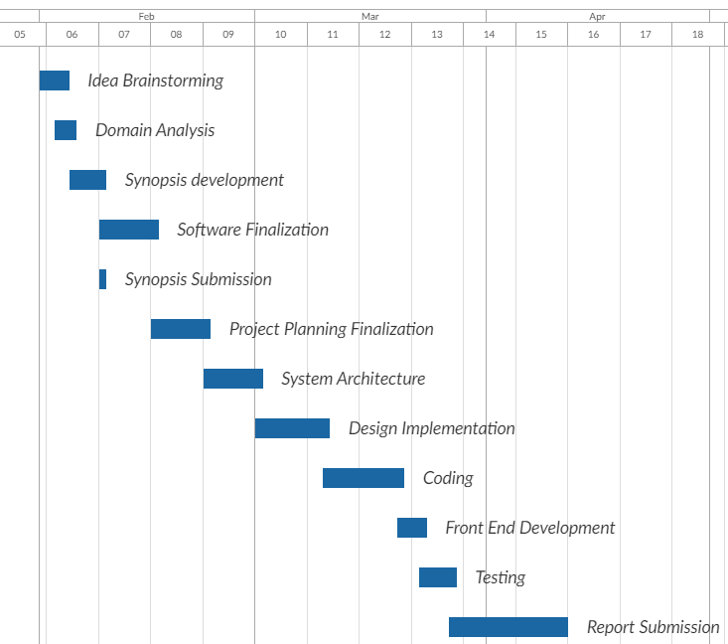
Fig 3.1 Gantt Chart

3.2 Risk identification
- Unfamiliar areas of the software take more time than expected to design and implement.
- The total features requested may be beyond what the development team can deliver in the time available.
- Requirements continue to change with time.
- The Administration Panel constantly updating.
4. SOFTWARE REQUIREMENT SPECIFICATIONS

4.1 Purpose
The purpose is to create a detailed and easy way to register the problem of the Client and visualizing the efficiency of the Employees.

4.2 Project scope
The scope of the software is to help the company identify its quality of service and have a record on the services provided by the company. It also helps the Company to identify the works of its employees to make sure of effective work and schedule them accordingly.
Also creating an interactive and easy interface for the customers to register complaints.

4.3 Overall description
4.3.1 Product perspectives
The purpose of this Software is to help the company to function in a more significant way for better accountability and proper documentation. The understanding of the resources and efficiency of the employees. The software creates an impact in the way servicing is done to the client and thus better credibility.

4.3.2 Product features
This product will have a page for the client to enter the complaints faced by them and tasks are assigned to the employees of the company where after the completion of the job they will be assigned with a new job and review of their service will be graded and the analysis will be done in the form of graphs depending on their reviews and tasks completed.

4.3.3 Operating environment

The software will operate with the following software components and applications:
- ATOM or Visual Studio Code
- MySQL
- Node.js
- Operating system:
- Windows10 or Linux

4.4 External interface requirements
4.4.1 User interfaces
- If a customer faces any issues, he can open the link and select a complaint from the drop down and provide a description of the same.
- The Customer upon placing the complaint will be issued with a token id for their reference.
- If the customer is unable to log a complaint through the portal, he can call the office and log a complaint orally. The front desk should manually log the complaint into the server.

4.4.2 Hardware interfaces
Server with least configuration of Intel Xeon E 5260904 (Octa Core), 17GHz, 20MB Cache with 1 x 300GB SAS (2.5" 10k RPM Hot Plug), SAS/SATA, 16Bays 2.5". The server should be built with 2 X RPS as it is meant to run round the clock to handle all the service requests and fetching database.

4.4.3 Software interfaces

Software | Visual Studio Code, MySQL, NodeJS
Operating System | Windows 10 or Linux
Front-end | JavaScript, HTML, CSS
Back-end | Node.js and Express
Database | MySQL
Table 4.4 Software Interfaces

4.4.4 Communication interfaces
NONE

4.5 System features
4.5.1 Functional requirements
Functional requirements are product features or functions that developers must implement to enable users to accomplish their tasks. So, it’s important to make them clear both for the development team. Generally, functional requirements describe system behavior under specific conditions. The software used are scalable to large domains and can be used on large network also. It can also be used to deployed on server to make sure it’s used by various number of clients.

4.5.2 Nonfunctional requirements

(a)Cost Reduction: Automation software is a better and more intelligent approach to cost containment and reduction. The greatest opportunity is to increase service to the customer (end user) while systematically reducing costs. Management often overlooks this potential for saving potential savings. Most modern servers have a low operating cost and the total cost of ownership has been declining Even so, the cost of the operations staff can be as high as 71% of the total cost. This can be significantly reduced by automating.

(b)Productivity: As an organization’s technology demands grow, productivity becomes a bigger concern. Typically, as other business areas were given tools to increase their productivity and effectiveness, IT operations took a back seat. The proliferation of automation software can create substantial gains in the office and overall business processes. But, instead of alleviating workload for the IT professionals in the back room, the spread of PCs has meant more tasks to be accomplished over a time consumed by manpower.

(c) Availability: Day-to-day business is routinely conducted with online systems: order entry, procurement assembly, logistics-the list goes on. If the computer is not available, the business suffers. Years ago, it was considered acceptable to have the computer unavailable for a few hours. Today, with the high volume of cloud computing, the outage of key systems can cost thousands of rupees in lost revenue and tarnish a company's reputation. A key advantage of automation.

(d) Reliability: Being reliable is the cornerstone of any good IT operations department and without it you have confusion, chaos, and unhappy users. IT operations requires two opposed skill sets: On one hand, an operations person needs highly technical skills, such as the ability to understand the complexities of an operating system and to analyze and solve problems as they arise. On the other hand, this same person has to be content pushing buttons and loading paper. Automated operations ensure that jobs are not forgotten or run out of sequence, that prerequisite jobs are completed successfully, that the input data is correct, and that any special processing is performed.

(e) Performance: Every company would like to have their enterprise perform like a thoroughbred. In reality, it is more likely to be overburdened with work. Even though advancements in computers make them faster and less expensive every year, the demands on them always catch up and eventually exceed the level of capability that a company's computer infrastructure possesses.
That leaves a lot of companies wanting to improve their system performance. Two options to improve performance are to upgrade hardware or purchase a new system--both expensive choices. It's also possible to tune a system for better performance, but this takes a highly skilled person who is not normally available 24 hours a day. And, once a system is tuned for a specific workload, if the workload changes, the settings are no longer optimum.

4.5.3 Use case description

Use Case Name | Fills complaint
Use Case Description | Describe the complaint
Actors | client
Trigger | User should visit the complaint website
Result | After successfully filling form.  Complaint is registered and details is sent to client in mail with preview of same in website.

Use Case Name | New service
Use Case Description | Request a new service
Actors | New user
Trigger | User should visit the new service page
Result | After successfully filling form.  The details are sent to admin.

Use Case Name | Track
Use Case Description | Track status of complaint
Actors | client
Trigger | User should visit the tracking page
Result | After entering complaint number. The status of the complaint is displayed if present.

Use Case Name | FAQ’s
Use Case Description | Get solutions for common or solved queries
Actors | client
Trigger | User should visit the FAQ page
Result | List of queries with its solutions.

Use Case Name | Employee login
Use Case Description | Employee logins and goes his complaint page
Actors | Employee
Trigger | Validation of login
Result | If a job assigned it is displayed.

Use Case Name | completed
Use Case Description | Job completed
Actors | Employee
Trigger | Completion of assigned job
Result | Status of employee and job is updated and if a new job is waiting it is assigned else employee waits for new task.

Use Case Name | Feedback
Use Case Description | Employee sends feedback of the job working
Actors | Employee
Trigger | An issue in the job
Result | If customer not present, job cannot be done, any equipment required or any other issue, employee sends feedback to admin regarding it.

Use Case Name | Customer feedback
Use Case Description | Customer send feedback on his job
Actors | client
Trigger | Upon his/her job completion.
Result | User provides rating and review of that job and is saved to that complaint.

Use Case Name | Admin dashboard
Use Case Description | Dashboard with graphs and statistics of the company.
Actors | Admin
Trigger | Validation of login
Result | Graphs and tables with employee data is displayed to analyze and other HR tools.

Use Case Name | HR tools
Use Case Description | Feature to improve company performance
Actors | Admin
Trigger | Selection of HR tools
Result | Can add/delete employee change task assigned or reject a task.

4.5.4 Use case diagram
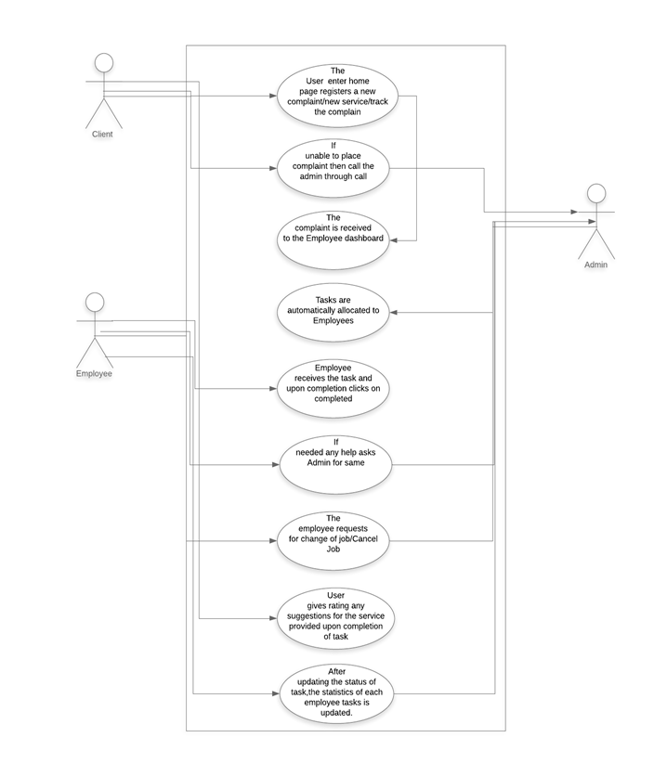
Fig 4.5 Use Case Diagram

5. DESIGN

5.1 Introduction

The current system existing today the company is using is manual where it’s difficult for them to manage records and their clients and unable to view their quality of service along with performance of their employees. In order to improve the standards of the work with proper documentation this software interface is developed which makes the clients also easier to track their complaints and even the company to manage the service requests they receive .The main goal is to automate the entire process and make sure they can handle past records and the complaints resolved by them. This also includes an Admin Dashboard which helps to get visualization on various fields which gives better understanding than numbers.

5.2 Architecture Design
Structure Diagram
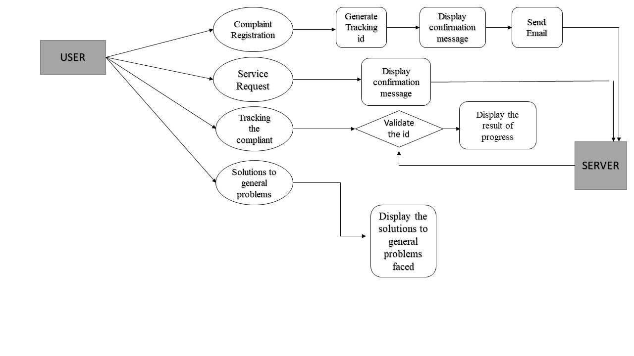
Fig 5.2.1 Structure Diagram of User
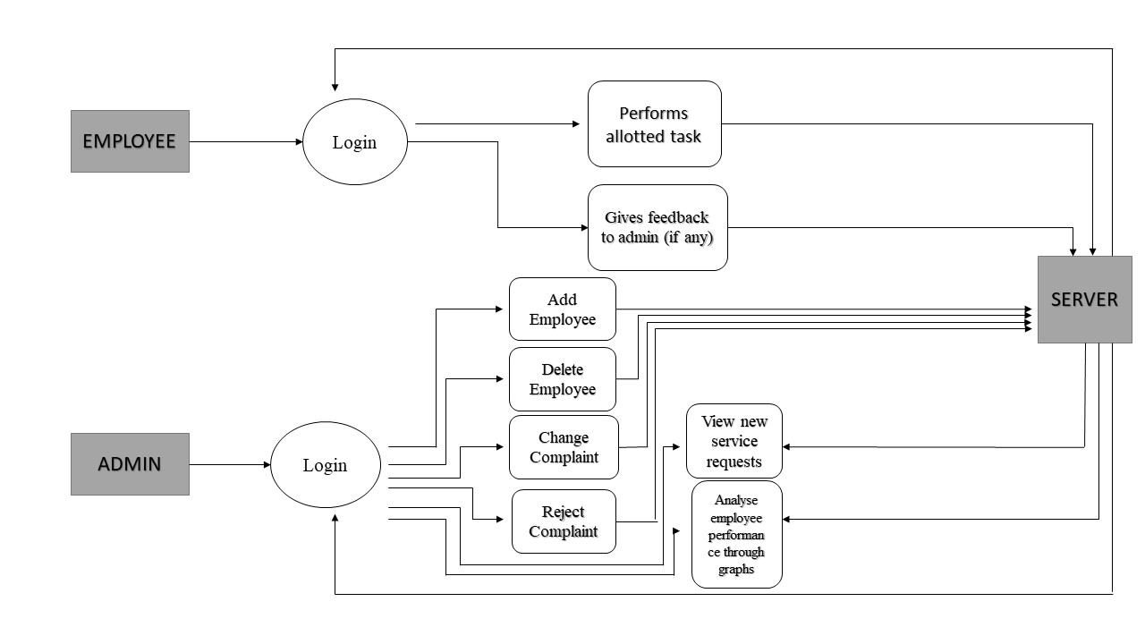
Fig 5.2.2 Structure Diagram of Employee and Admin

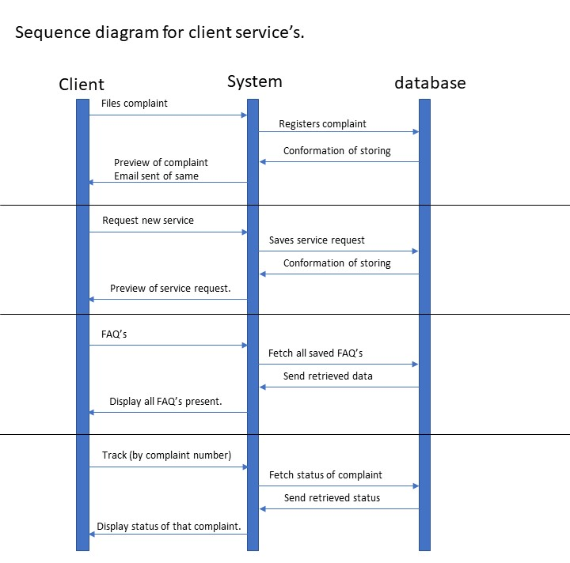
5.3 Sequence Diagrams
Fig 5.3.1 Sequence Diagram for client services

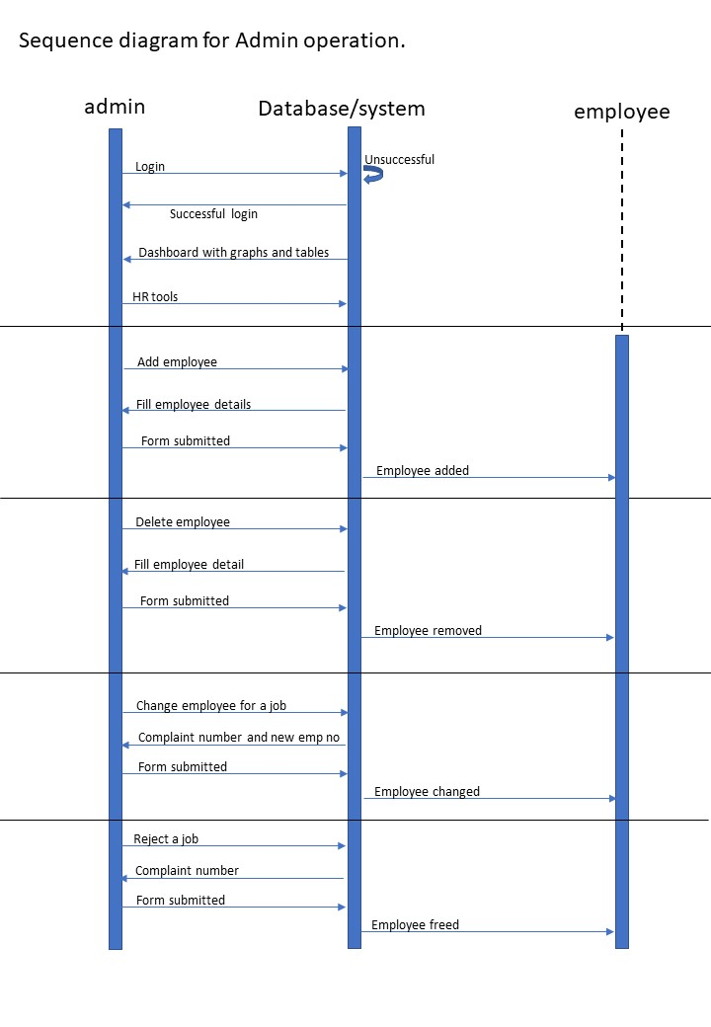
Fig 5.3.2 Sequence Diagram for Admin operation

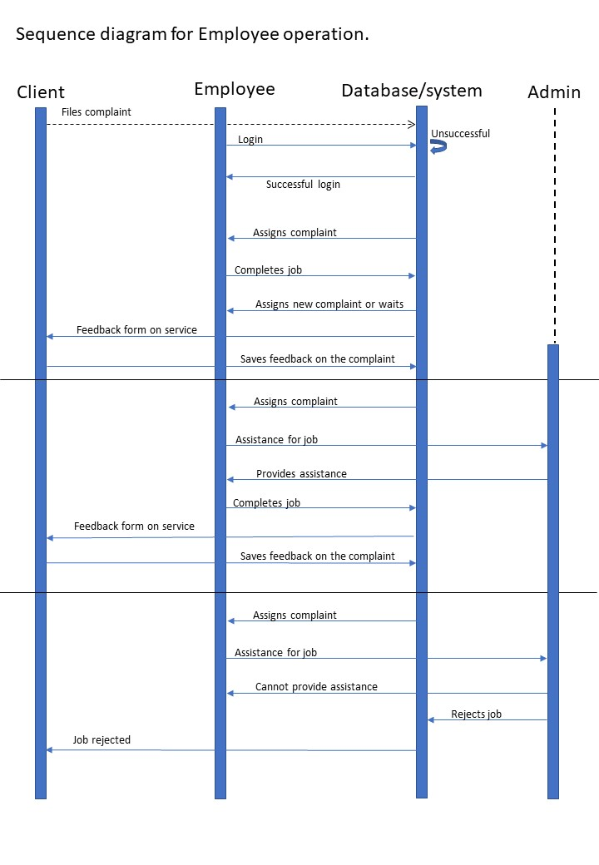

Fig 5.3.3 Sequence Diagram for Employee operation

5.4 Conclusion

The main focus of this work is to create a business solution easier for accessibility and scalable on large platforms. It helps to have an overview on the progress of the company. It develops a better documentation of the progresses done by the company. Help the employees to improve their performance and quality of service and attain optimal results. It also creates an interface for the admin to view the overall development of its employees and track its future projects along with its business expansions by its quality service.

6.IMPLEMENTATION

6.1 Technology Introduction
The technologies being used are:
Node.Js-Node.js is a platform built on Chrome’s JavaScript runtime for easily building fast and scalable network applications. Node.js uses an event-driven, non-blocking I/O model that makes it lightweight and efficient, perfect for data-intensive real-time applications that run across distributed devices.
Express.Js- Express is a minimal and flexible Node.js web application framework that provides a robust set of features to develop web and mobile applications. It facilitates the rapid development of Node based Web applications. Following are some of the core features of Express framework −
- Allows to set up middlewares to respond to HTTP Requests.
- Defines a routing table which is used to perform different actions based on HTTP Method and URL.
- Allows to dynamically render HTML Pages based on passing arguments to templates.

HTML5-This was used for the designing of the application.HTML stands for Hyper Text Markup Language. It is used to design web pages using markup language. HTML is the combination of Hypertext and Markup language. Hypertext defines the link between the web pages. Markup language is used to define the text document within tag which defines the structure of web pages.

6.2 Explanation of Algorithms and how it’s being implemented -
Queue for auto-assign task for employee and Algorithm implemented is as follows-

function Queue() {
var a = [];
this.getLength = function() {
return a.length
};
this.list = function() {
return a
};
this.isEmpty = function() {
return 0 == a.length
};
this.addemp = function(b) {
if (a.includes(b) || false) {
this.addemp(++b);
} else {
a.push(b)}
};
this.popid = function(i) {
var index = a.indexOf(i);
if (index > -1) {
a.splice(index, 1);
}
};
this.popemp = function() {
if (0 != a.length) {
var c = a[0];
a.splice(0, 1);
return c;
}
};
this.peek = function() {
var b = 0
return 0 < a.length ? a[b] : void 0
}
};
Here a custom queue (FIFO model) is used as a task can be changed to a different employee, a new employee can be assigned a task of employers choice and reject a complain.
- Getlength() provides no of employees currently not working on a task.
- List() provides with list of all employees in queue
- isEmpty() provides boolean result for any employees available or not.
- addemp(b) adds employee with id ‘b’ into end of queue.
- Popid(i) pops employee with id ‘i’ from queue.
- Popemp() pops employee in beginning of queue.
- Peek() provides employee id at beginning of queue without popping it.

6.3 Information about Implementations of Modules –

Express.Js – Express is a minimal and flexible Node.js web application framework that provides a robust set of features for web and mobile applications. It is an open source framework developed and maintained by the Node.js foundation.

Multer- Multer is a node. js middleware for handling multipart/form-data , which is primarily used for uploading files. It is written on top of busboy for maximum efficiency.

Body-Parser - Body Parser is a middleware of Node JS used to handle HTTP POST request. Body Parser can parse string-based client request body into JavaScript Object which we can use in our application

Nodemailer - The Nodemailer module makes it easy to send emails from your computer. This module is used to send confirmation messages to the clients upon registering a complaint and link after task completion to provide feedback.
7. TESTING
7.1 Introduction
Testing involves running the code with different inputs and tracking the performance of the POS system. Testing of the POS System is done to ensure proper and flawless performance of the application.

7.2 Test Cases

Test Case ID | Test1
Test Description | Report an issue (by user)
Input | Name, Email ID, subject, detailed description of complaint, attachment
Expected Output | Conformation message is displayed and mail is sent to client.
Actual Output | Confirmation message is displayed mail is sent to client.
Test Result | PASS

Test Case ID | Test2
Test Description | Check the progress (by user)
Input | Tracking ID
Expected Output | The status of complaint is displayed
Actual Output | The status of complaint is displayed
Test Result | PASS

Test Case ID | Test3
Test Description | Check the progress (by user)
Input | Tracking ID(incorrect id)
Expected Output | This tracking id doesn't exit.! Check and enter your id once again
Actual Output | This tracking id doesn't exit.! Check and enter your id once again
Test Result | PASS

Test Case ID | Test4
Test Description | Employee Login
Input | Employee ID and password
Expected Output | Employee Login successful
Actual Output | Employee Login successful
Test Result | PASS

Test Case ID | Test5
Test Description | Wrong emp login credentials.
Input | Wrong credentials as id and password
Expected Output | “not registered employee”.
Actual Output | “not registered employee”.
Test Result | PASS

Test Case ID | Test6
Test Description | Admin Login
Input | Login ID and password
Expected Output | Admin Login successful
Actual Output | Admin Login successful
Test Result | PASS

Test Case ID | Test7
Test Description | Admin Login
Input | Incorrect Login ID and password
Expected Output | Redirect to login page again
Actual Output | Redirect to login page again
Test Result | PASS

Test Case ID | Test8
Test Description | View New Service Requests
Input | NONE
Expected Output | New service requests from past one week are displayed
Actual Output | New service requests from past one week are displayed
Test Result | PASS

Test Case ID | Test9
Test Description | Send feedback to admin
Input | Feedback details
Expected Output | Feedback sent successfully
Actual Output | Feedback sent successfully
Test Result | PASS

Test Case ID | Test10
Test Description | Completed.
Input | none
Expected Output | “Good job” or “new task assigned”.
Actual Output | “Good job” or “new task assigned”.
Test Result | PASS

Test Case ID | Test11
Test Description | Provide feedback for service
Input | Rating and review
Expected Output | Feedback registered successfully.
Actual Output | Feedback registered successfully.
Test Result | PASS

Test Case ID | Test12
Test Description | View Employee Feedback
Input | NONE
Expected Output | Feedbacks given by employees are displayed
Actual Output | Feedbacks given by employees are displayed
Test Result | PASS

Test Case ID | Test13
Test Description | Change a complaint
Input | Complaint number and new employee ID
Expected Output | Complaint is transferred to new employee with current date as start date
Actual Output | Complaint is transferred to new employee with current date as start date
Test Result | PASS

Test Case ID | Test14
Test Description | Cancel a complaint
Input | Complaint number
Expected Output | Complaint is rejected
Actual Output | Complaint is rejected
Test Result | PASS

Test Case ID | Test15
Test Description | Add an employee
Input | Employee ID, name, email id, phone number, password
Expected Output | Employee added successfully
Actual Output | Employee added successfully
Test Result | PASS

Test Case ID | Test16
Test Description | Delete an employee
Input | Employee ID
Expected Output | Employee deleted successfully
Actual Output | Employee deleted successfully
Test Result | PASS

Test Case ID | Test17
Test Description | List of complaints with filter.
Input | (if required) Date or emp id ,status of comlaint
Expected Output | List of complaints with filtered result based on filter provided.
Actual Output | List of complaints with filtered result based on filter provided.
Test Result | PASS

Test Case ID | Test18
Test Description | Feedback without a complaint
Input | none
Expected Output | “can’t send feedback without a task assigned”.
Actual Output | “can’t send feedback without a task assigned”.
Test Result | PASS

Test Case ID | Test19
Test Description | Change complaint to a busy employee
Input | Busy employee
Expected Output | “Employee already on a task”.
Actual Output | “Employee already on a task”.
Test Result | PASS

Test Case ID | Test20
Test Description | Incorrect Cancel complaint
Input | Incorrect complaint number
Expected Output | “Complaint is either completed or not found”  “enter correct complaint number”
Actual Output | “Complaint is either completed or not found”  “enter correct complaint number”
Test Result | PASS

8.RESULTS & PERFORMANCE ANALYSIS

8.1 Result Snapshots:

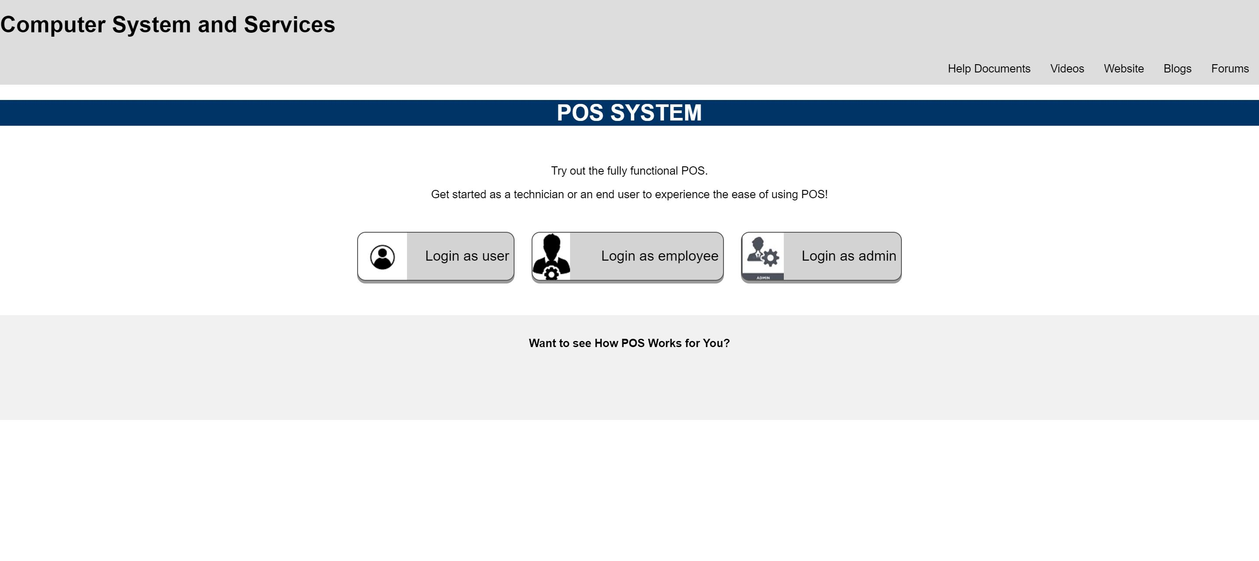
Fig 8.1.1 Homepage

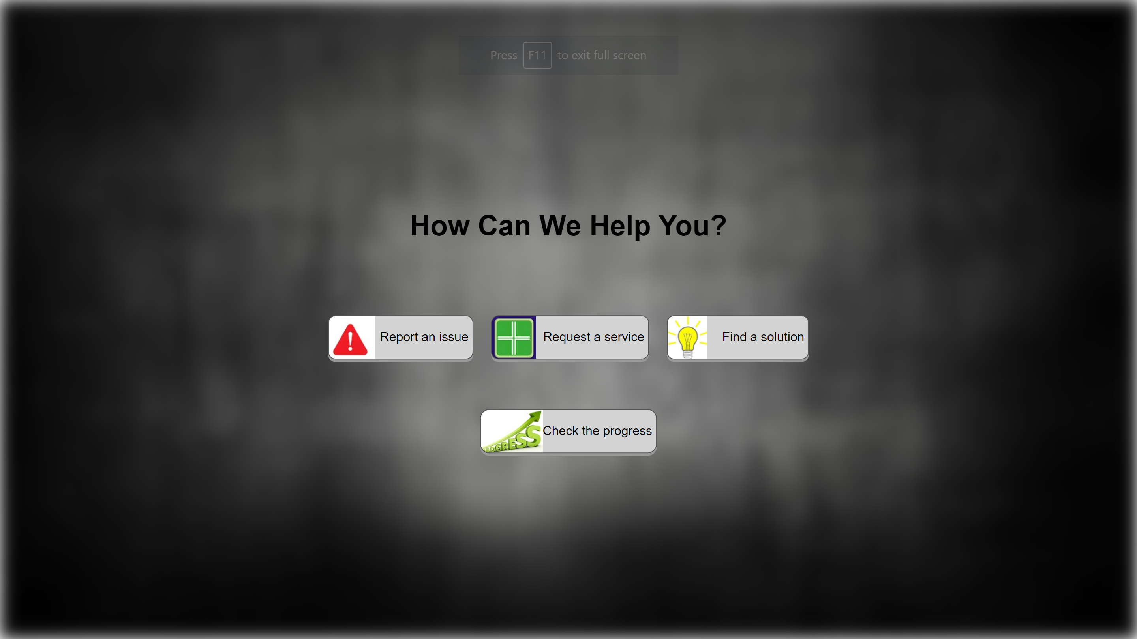
Fig 8.1.2 User (Login as User)

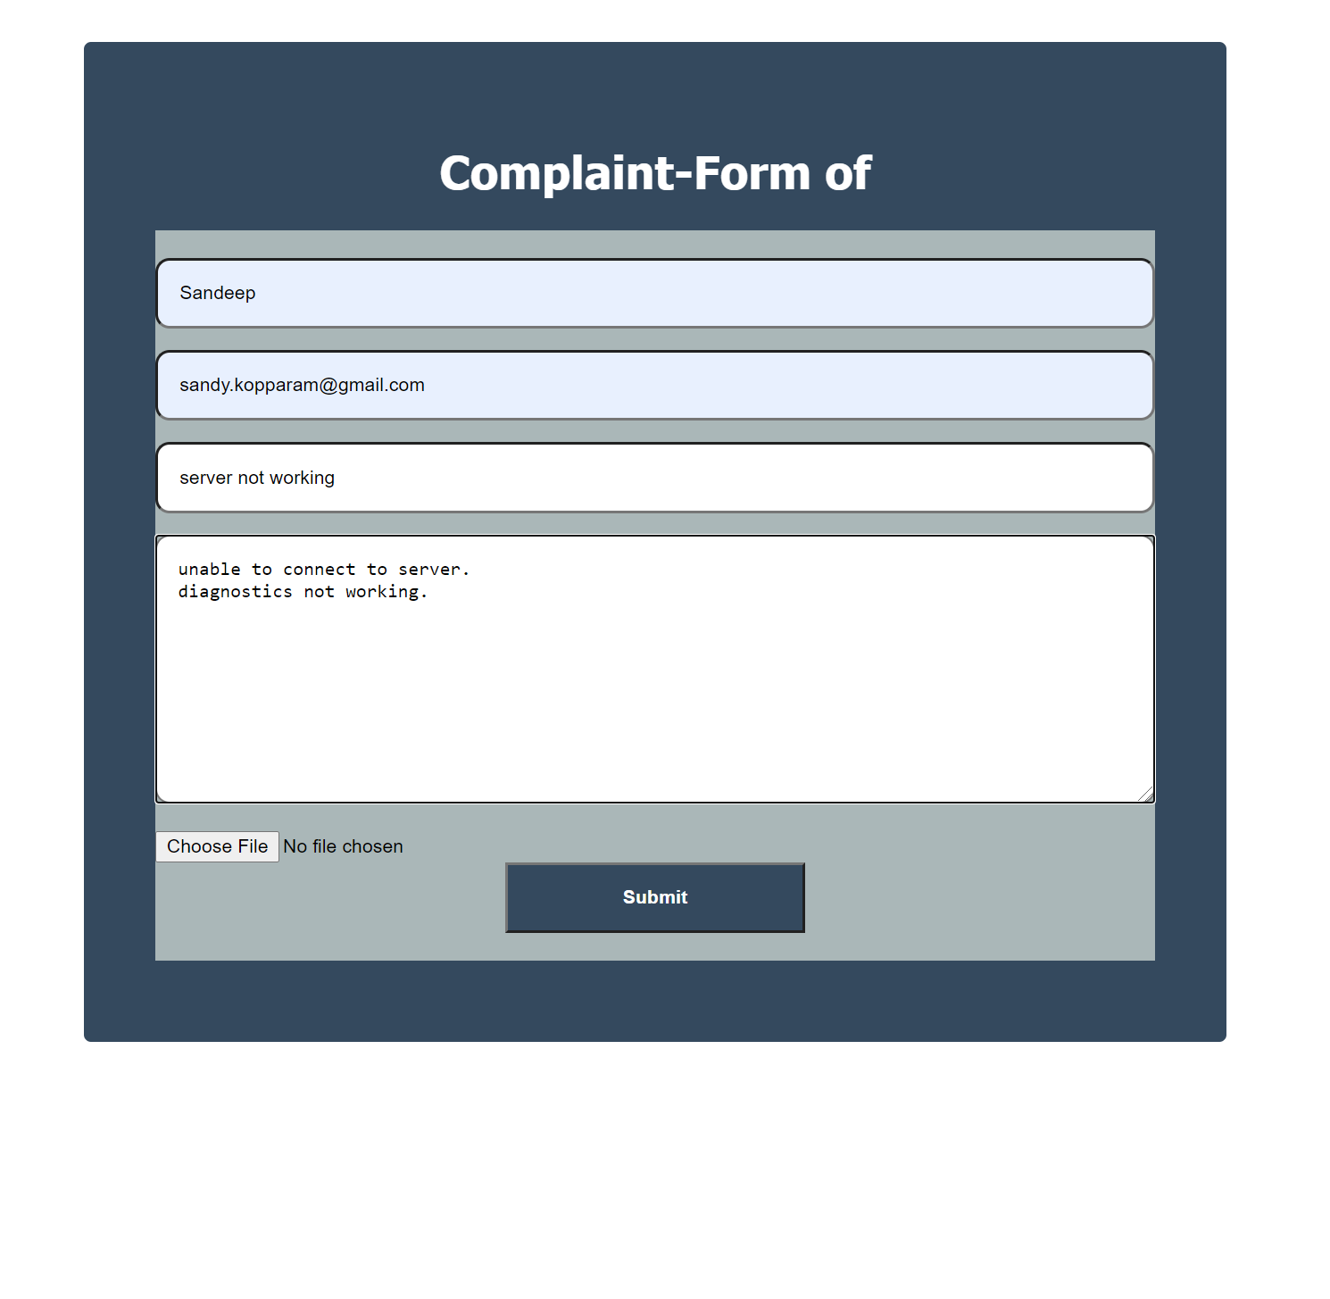
Fig 8.1.3 Reporting an issue:

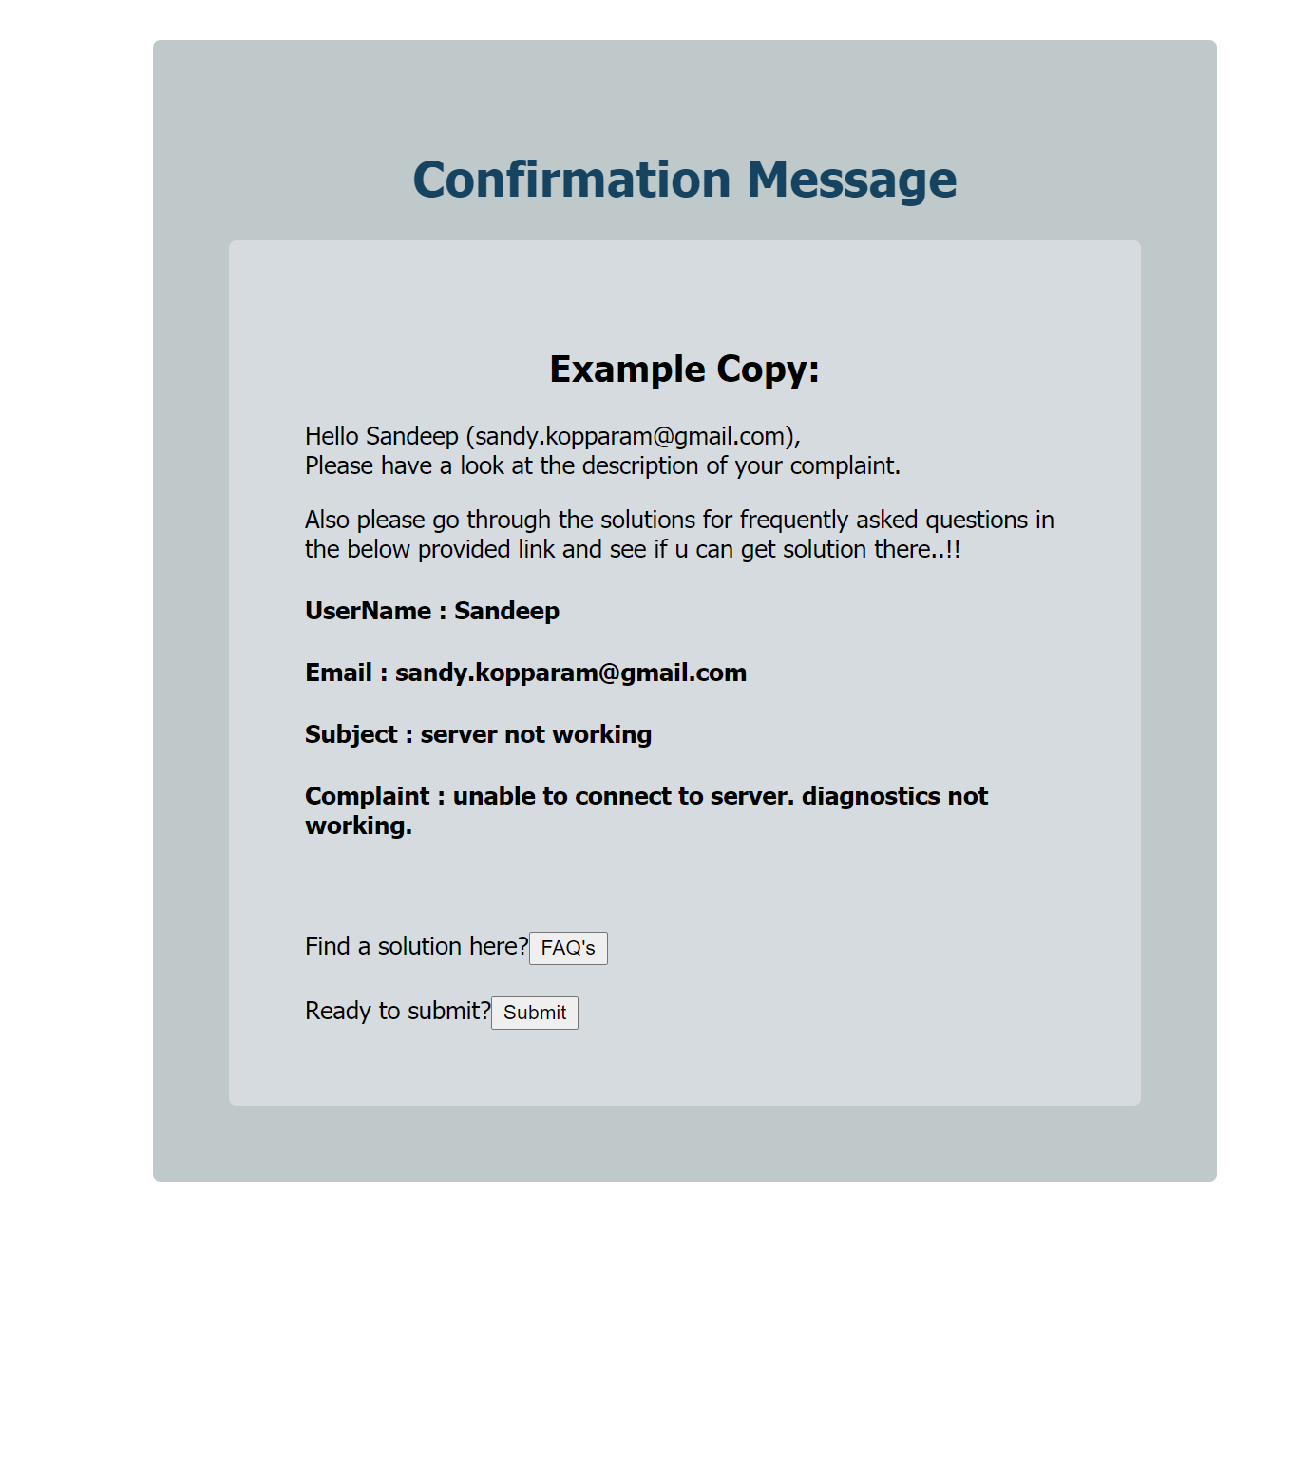
Fig 8.1.4 Conformation Token
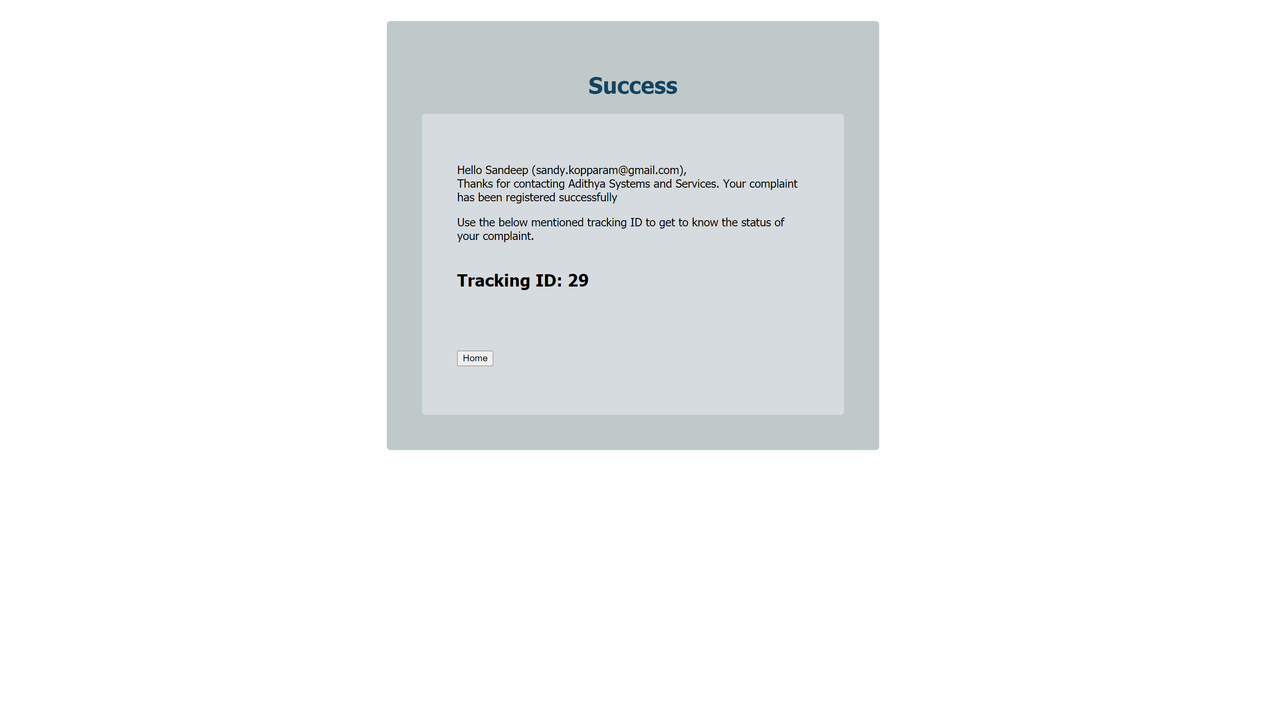

Fig 8.1.5 Message after submission of complaint
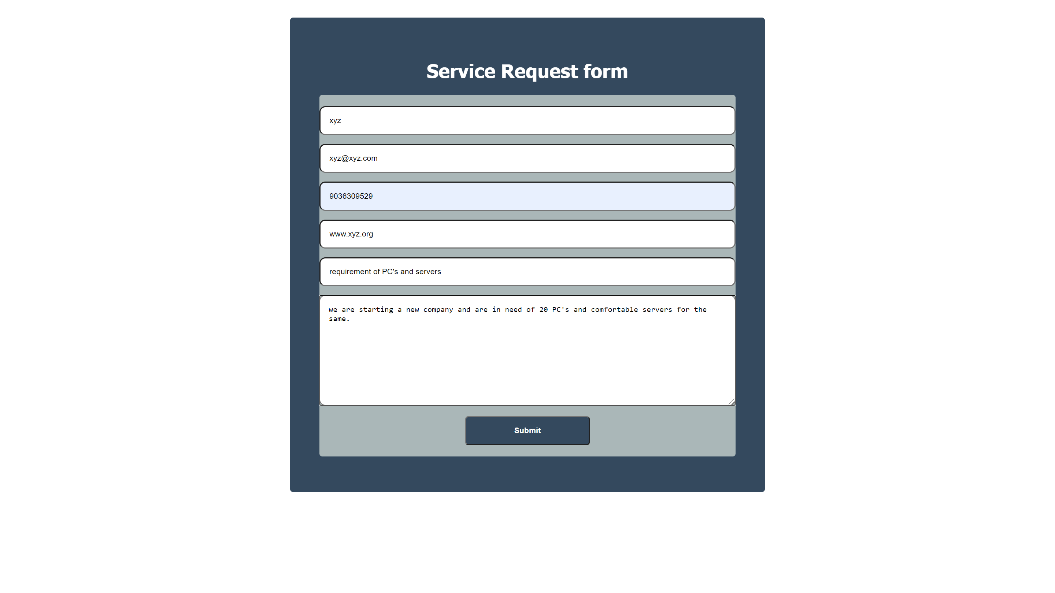

Fig 8.1.6 New Service Request
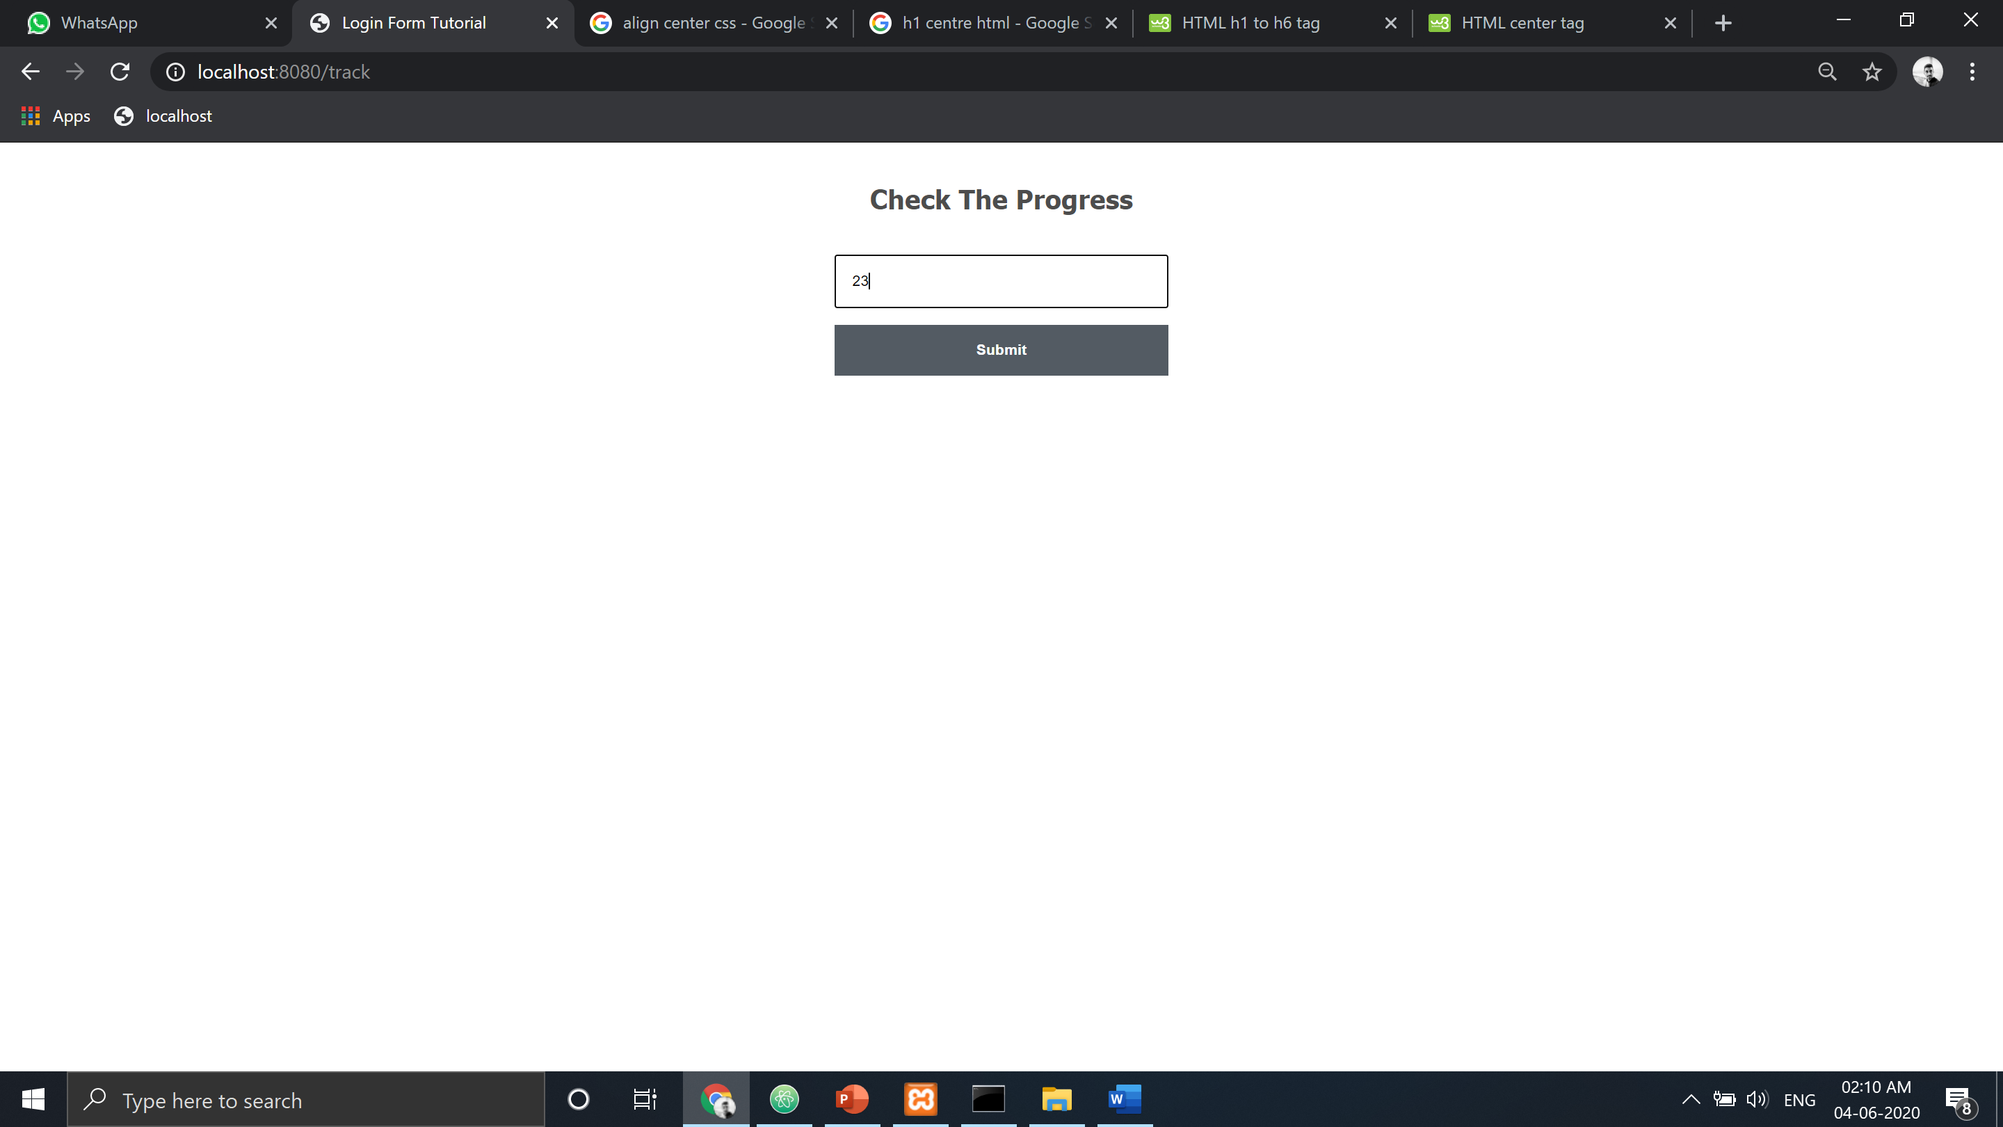
Fig 8.1.7 Tracking the progress of complaint
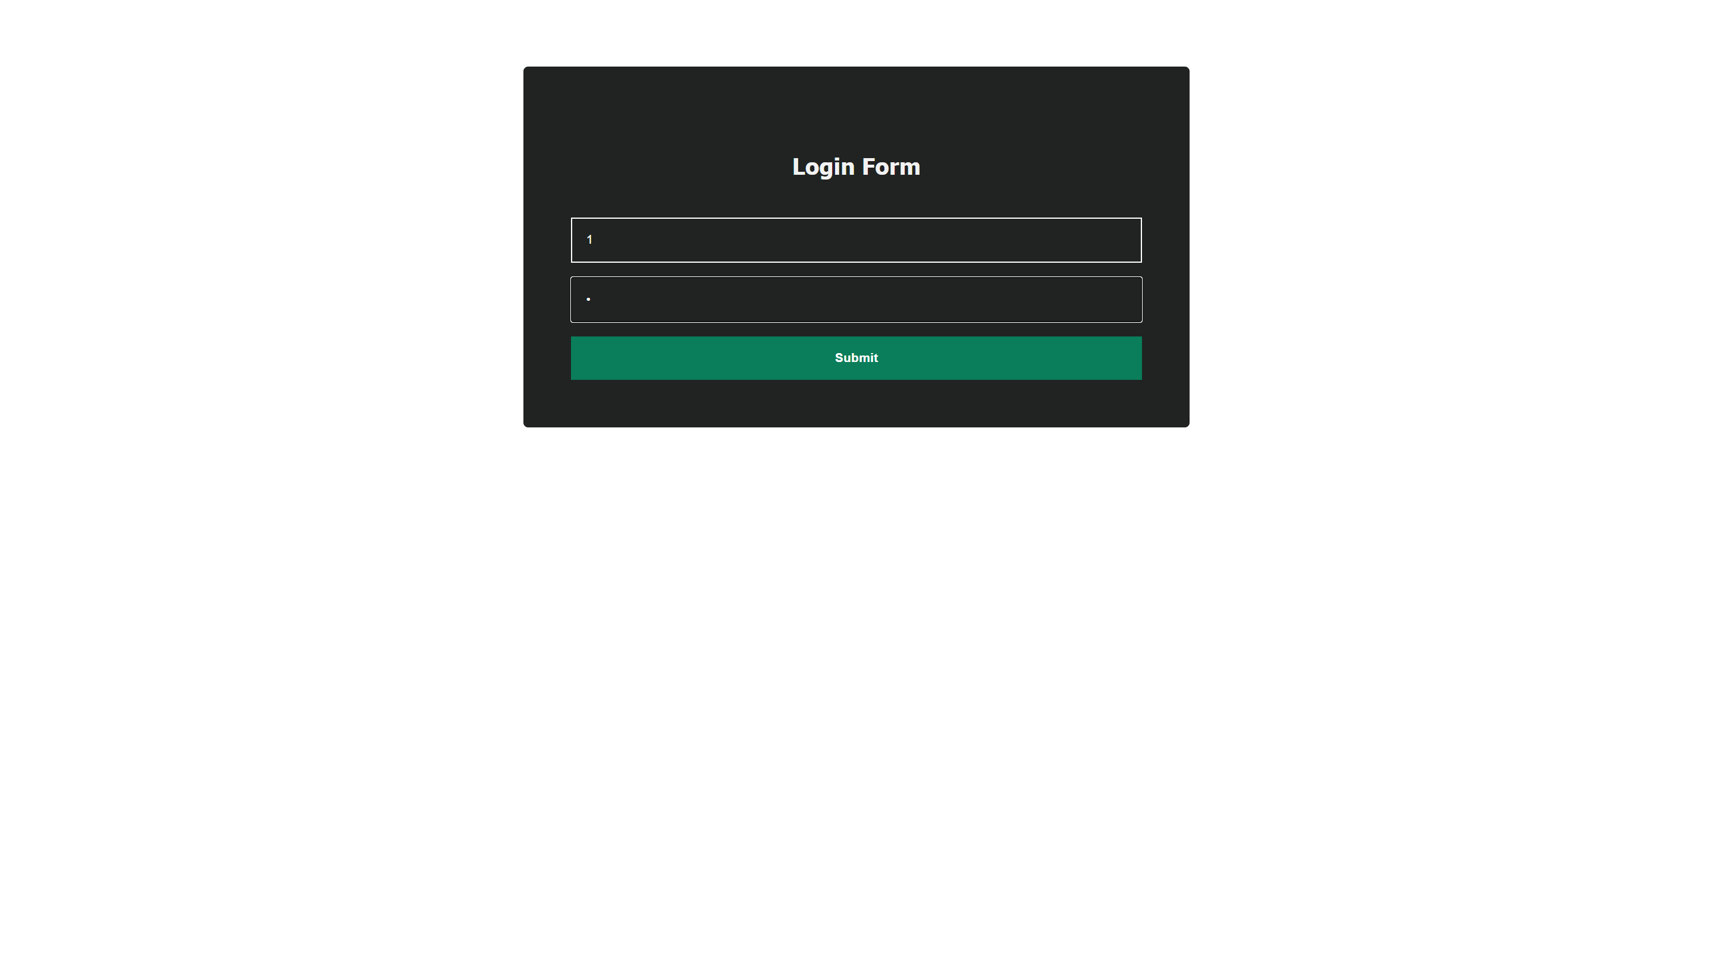

Fig 8.1.8 Employee Login

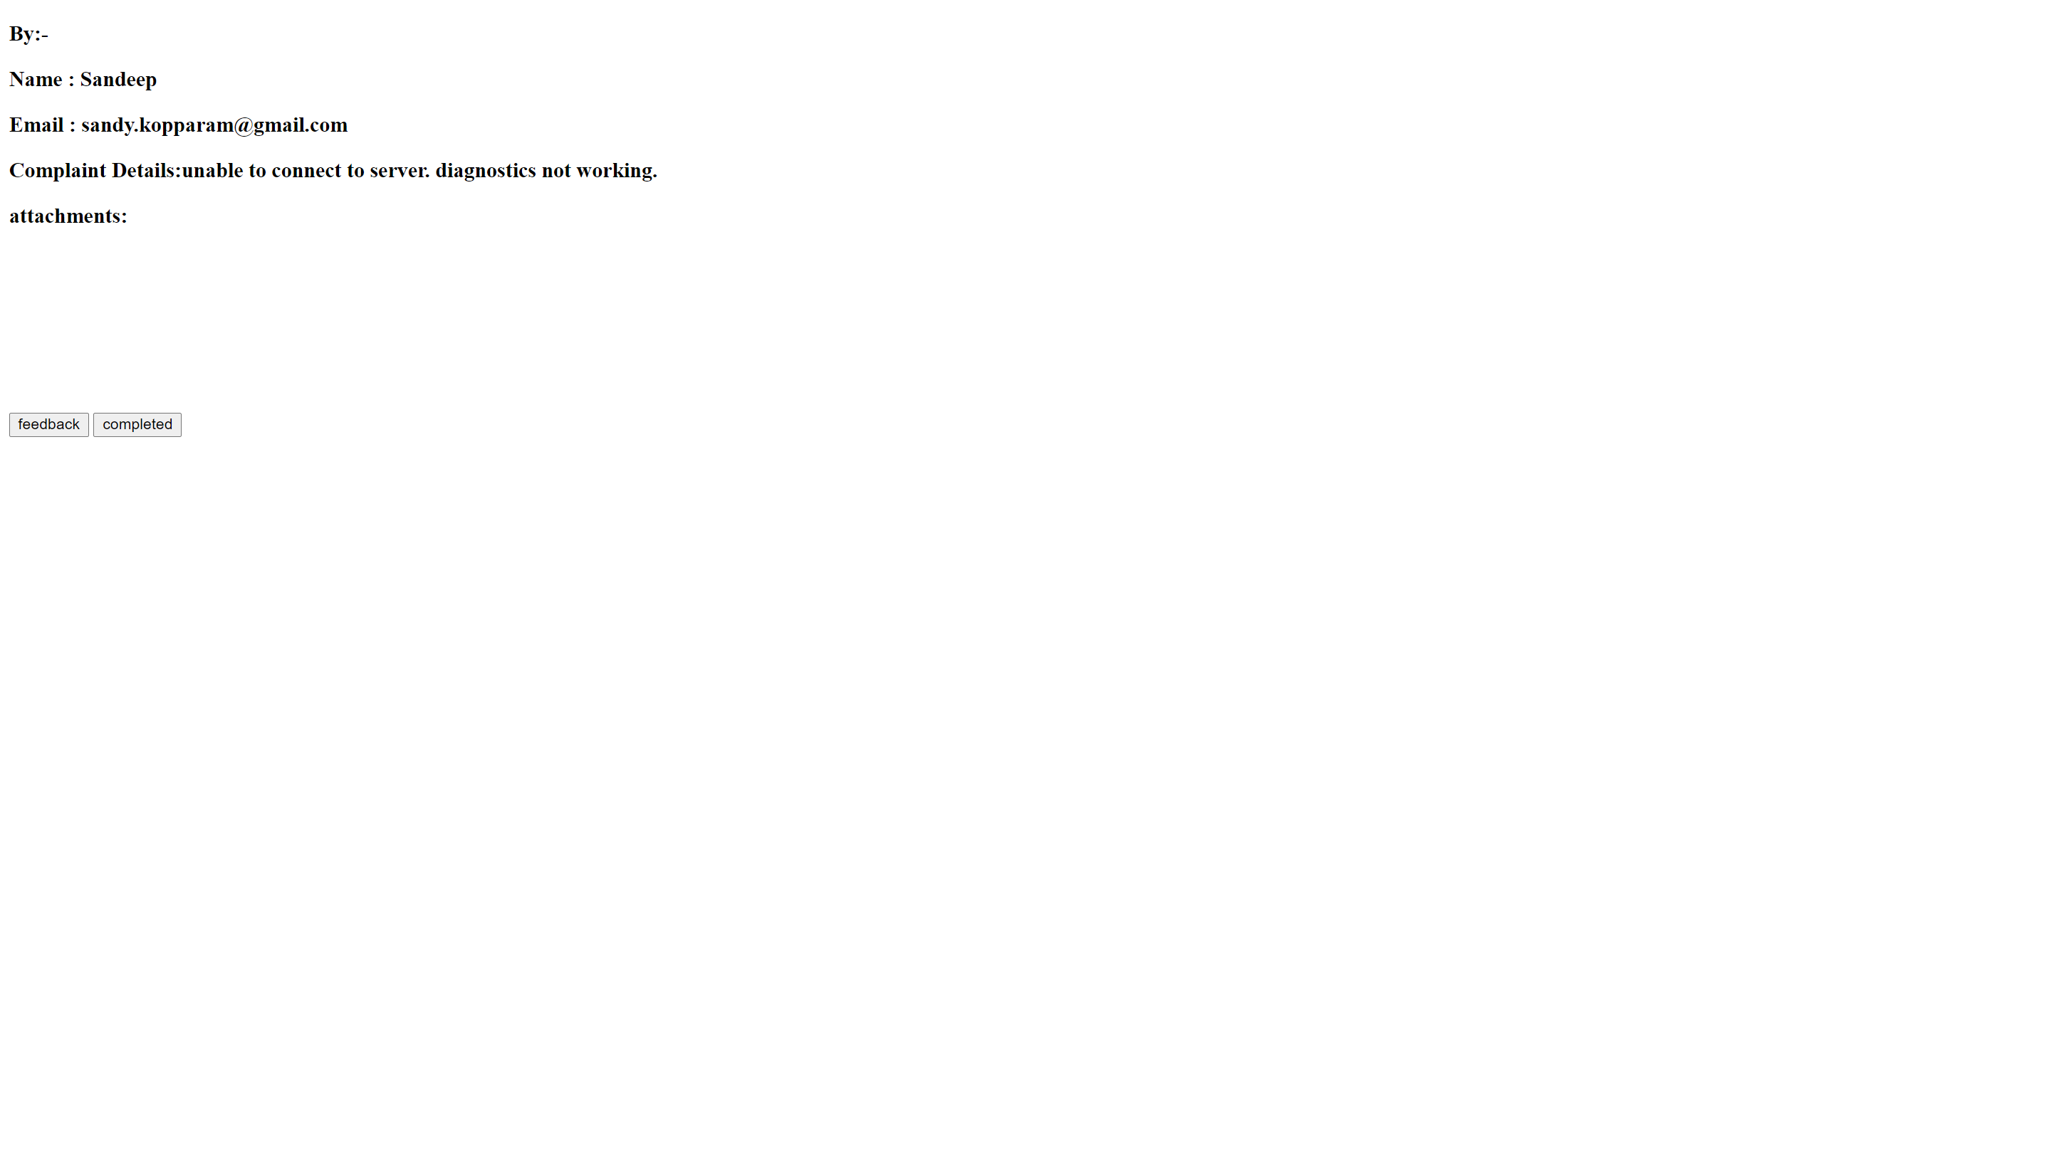

Fig 8.1.9 Employee Task page

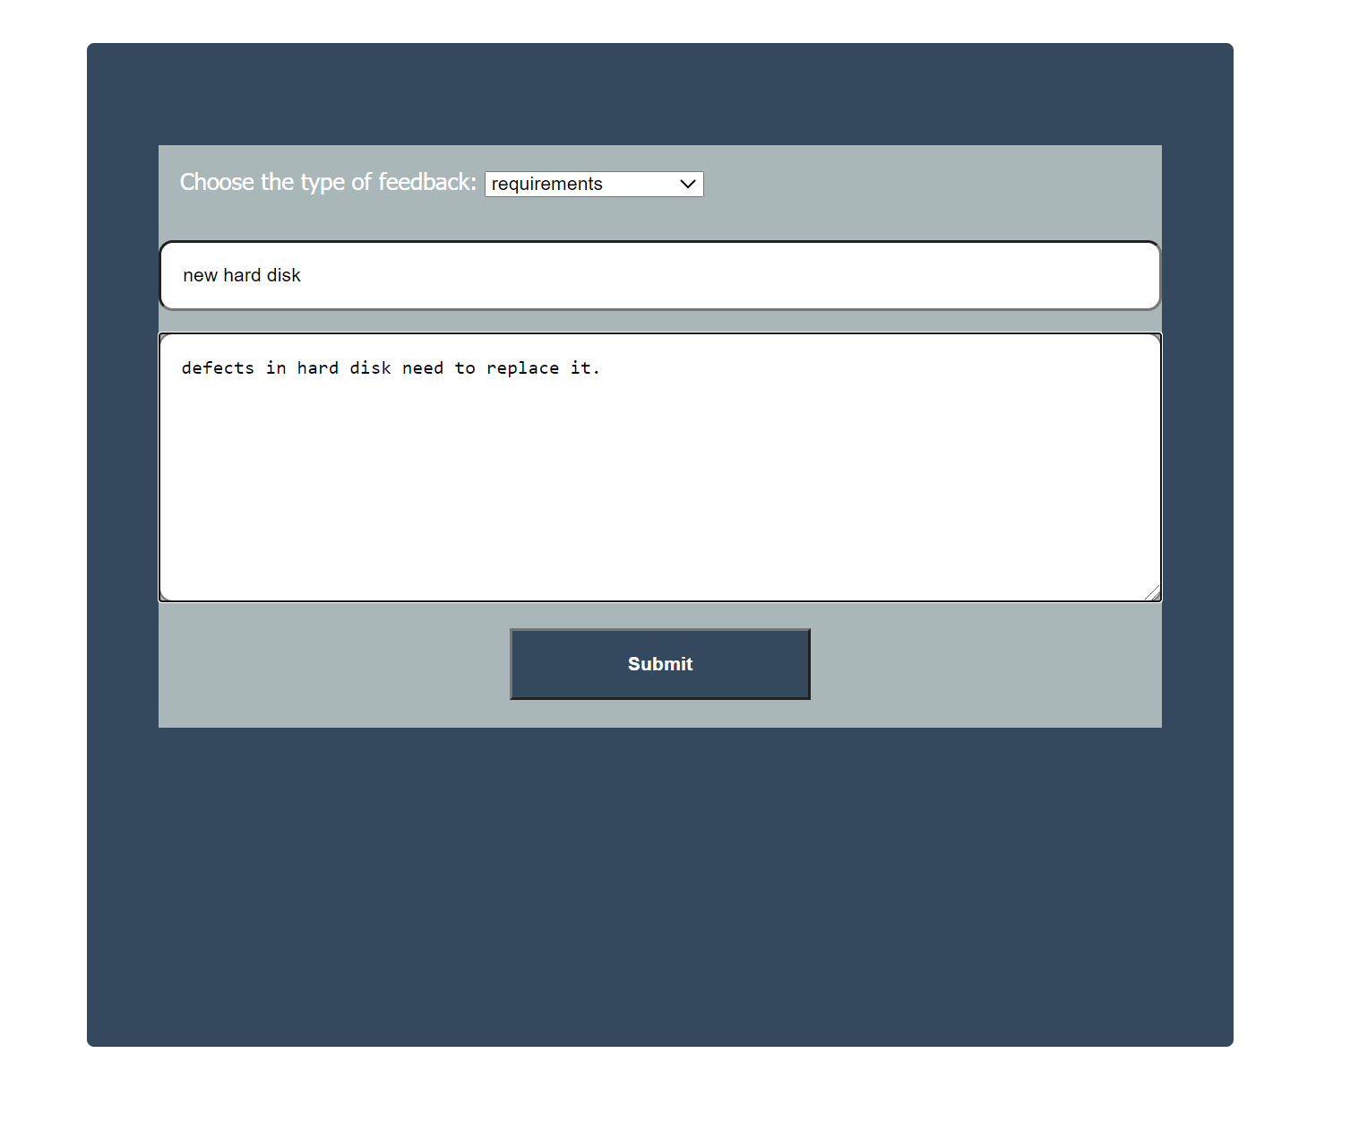
Fig 8.1.10 Feedback form for Employee

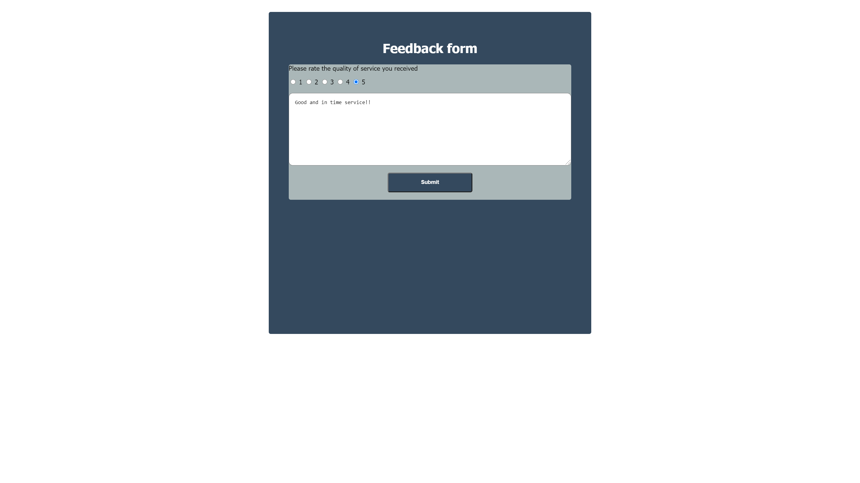

Fig 8.1.11 Feedback form for User
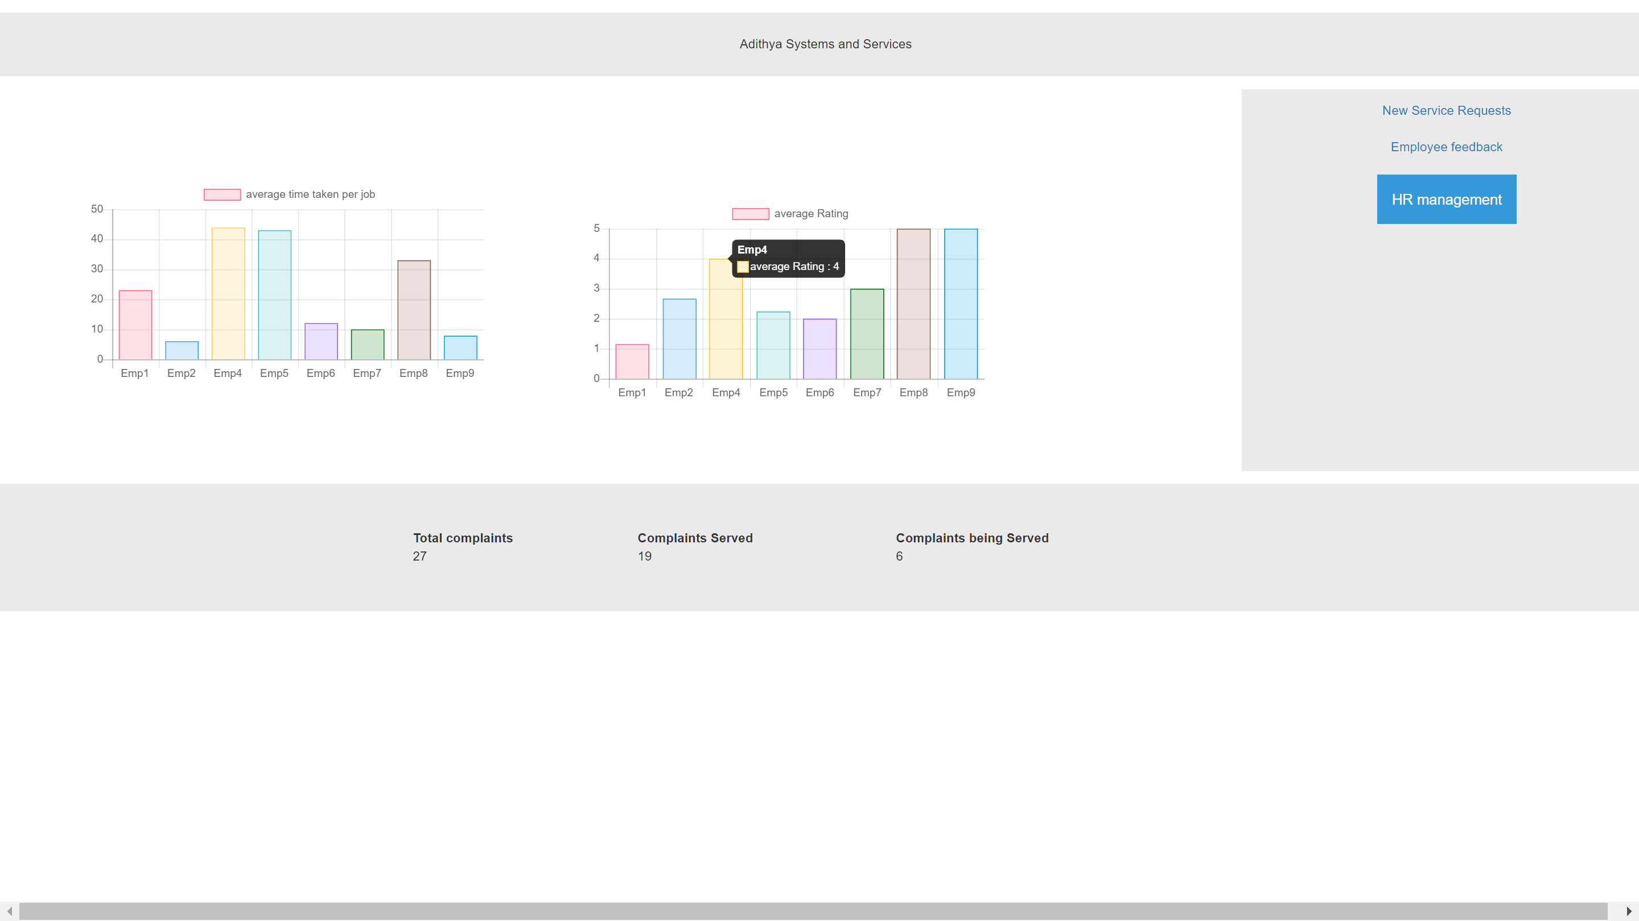

Fig 8.1.12 Admin Dashboard
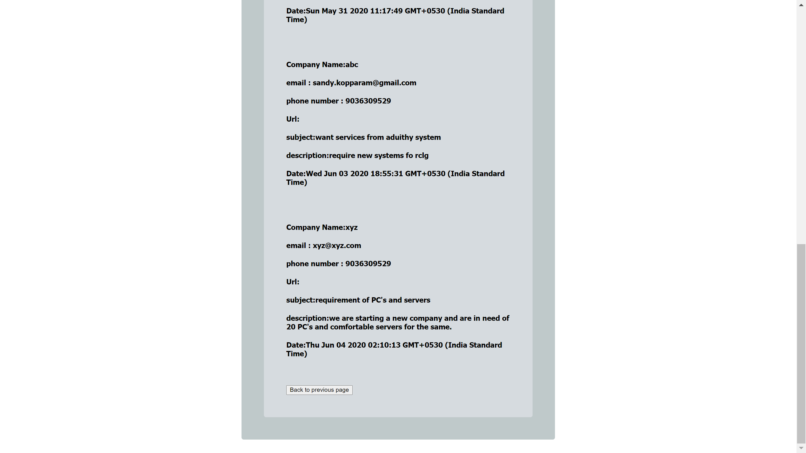

Fig 8.1.13 Viewing New Service Requests
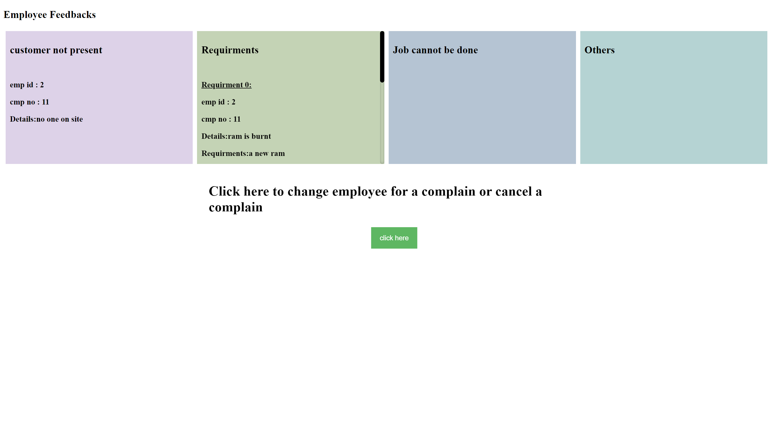

Fig 8.1.14 Viewing Employee feedbacks

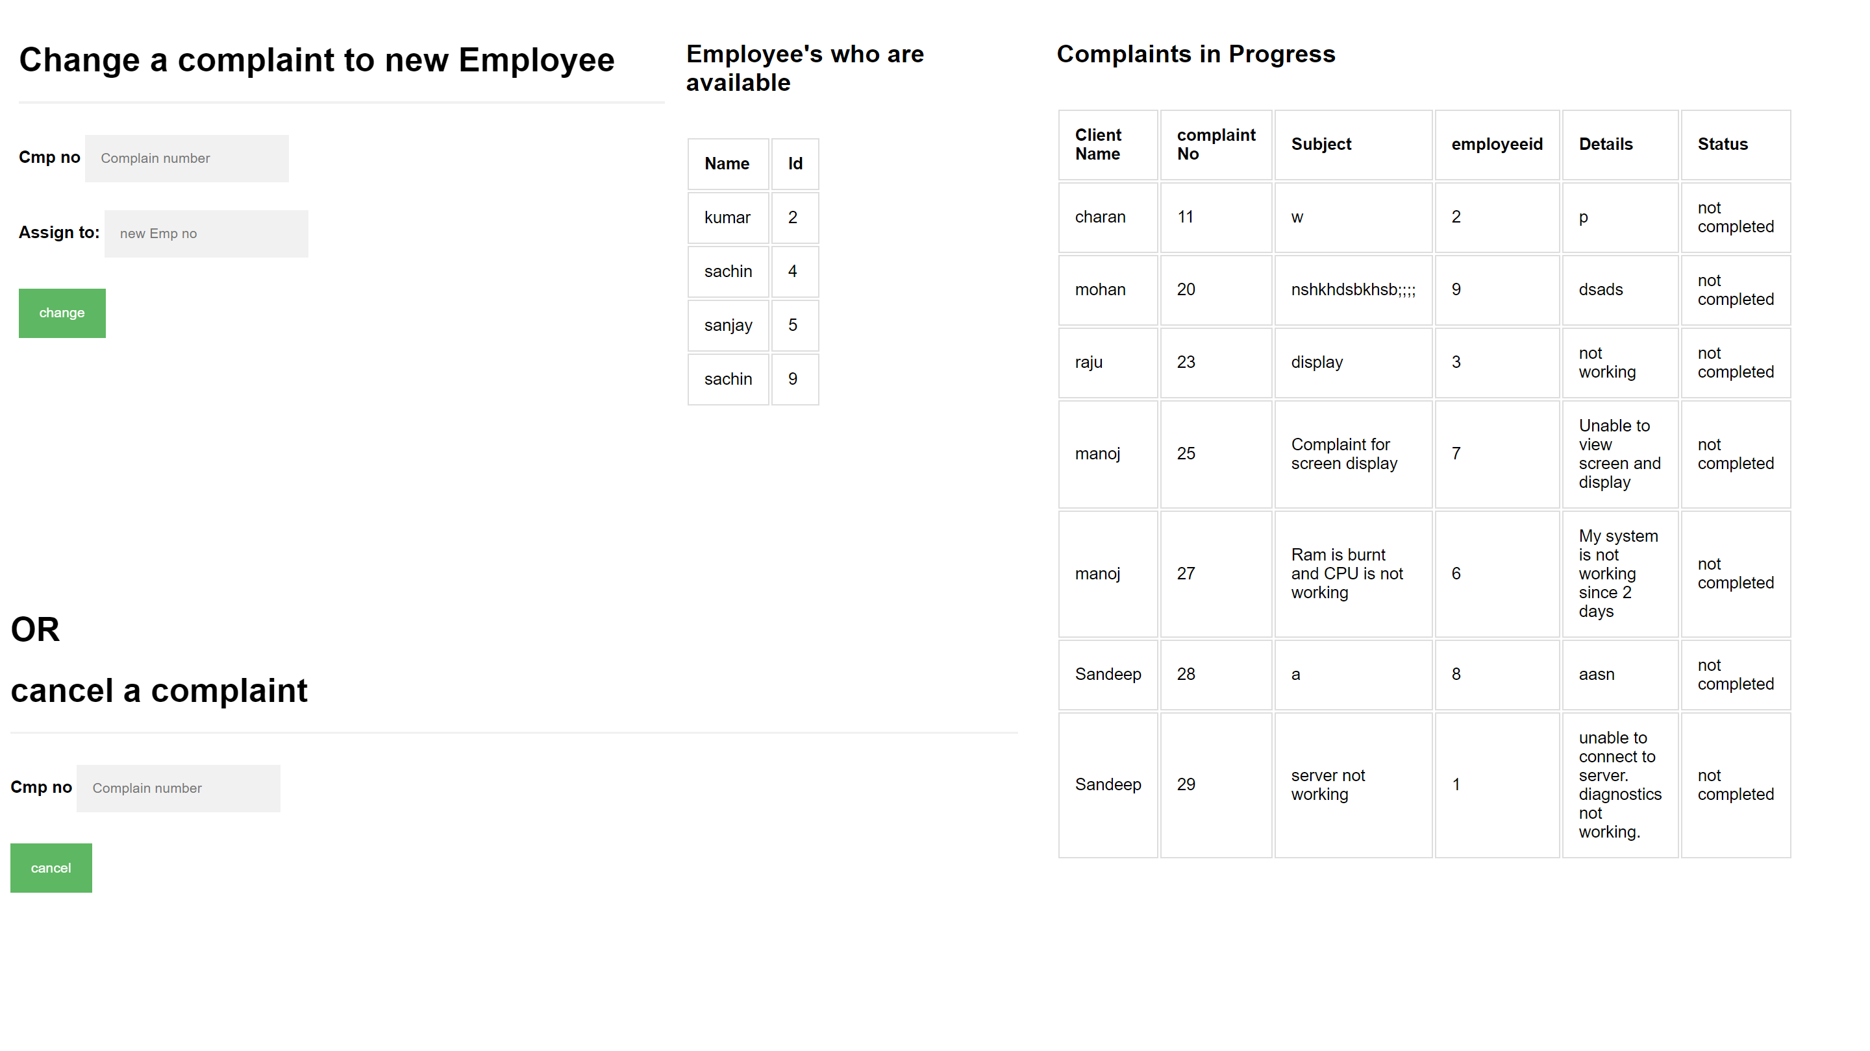

Fig 8.1.15 Changing or cancelling a complaint

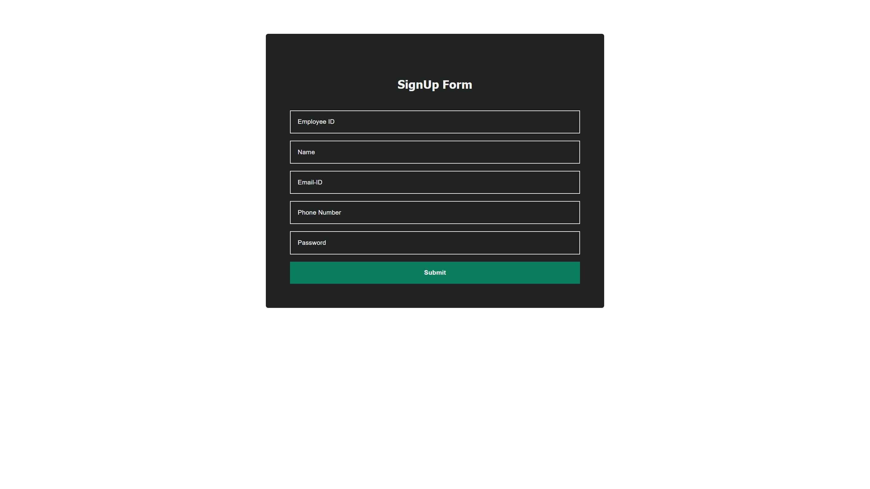

Fig 8.1.16 Adding an Employee

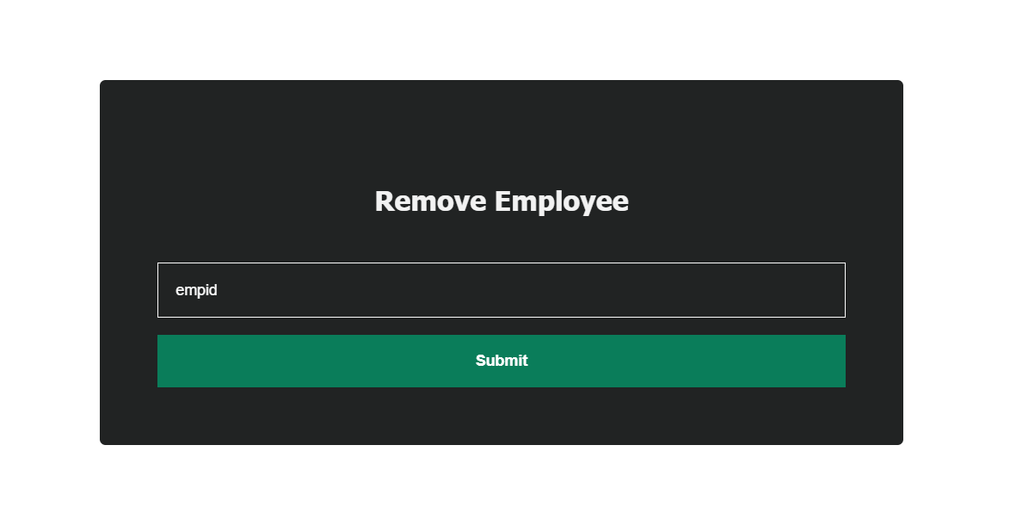

Fig 8.1.17 Removing an Employee

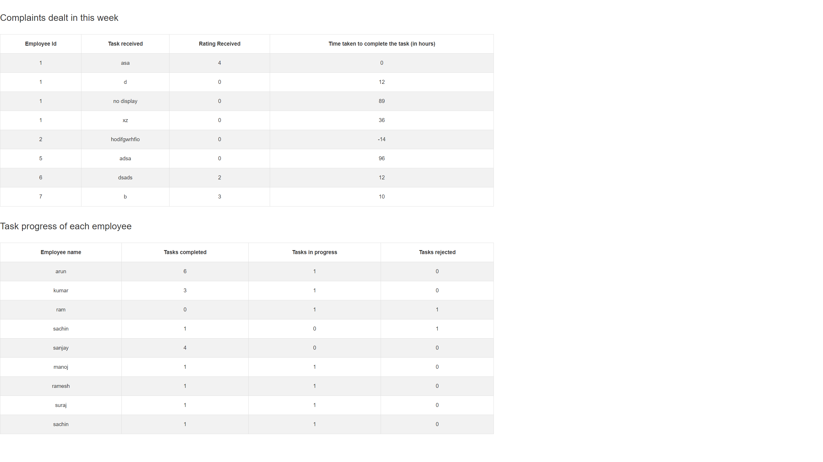

Fig 8.1.18 Progress of the week based on Employee

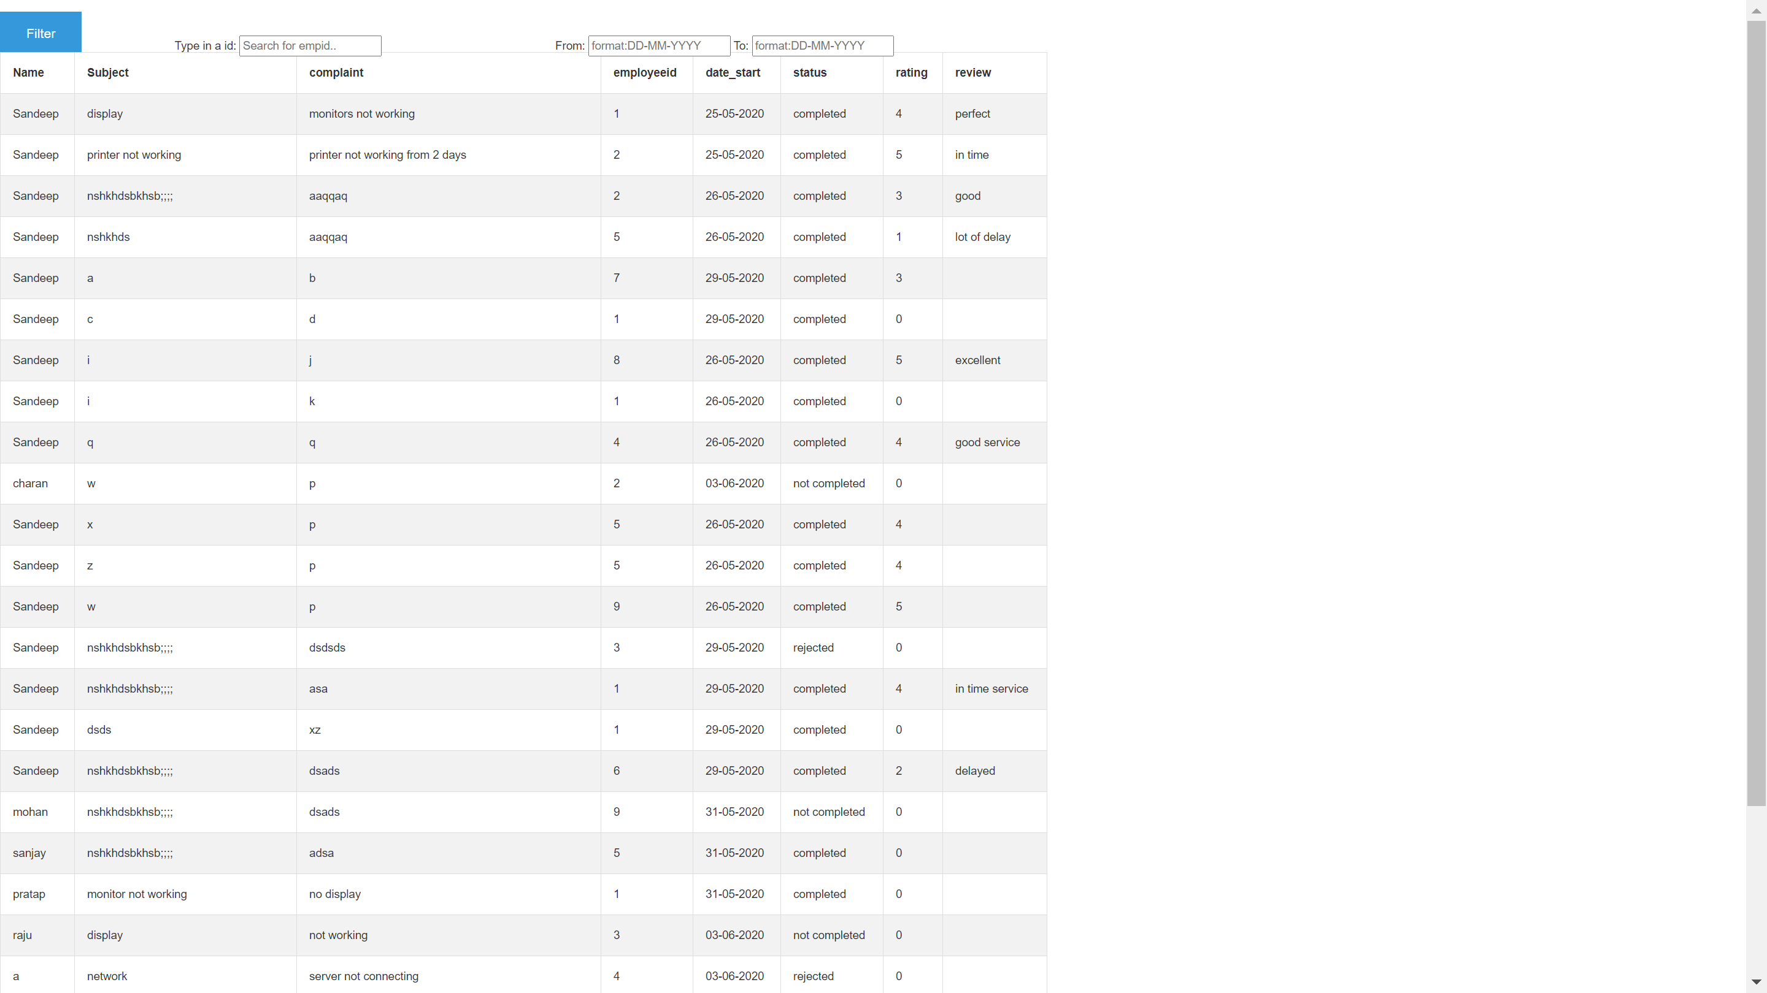

Fig 8.1.19 List of all complaints with filter options

9.CONCLUSION & SCOPE FOR FUTURE WORK

9.1 Limitation of this Work

- Employer should intervene if any requirements, queries from employee for a job rather than automated handling of same.

- Identifying Complicated jobs and assigning same to an efficient employee.

- Simple Chat box for employees to help out each other.

9.2 Directions for the Future works:

The above limitations also have important scope in future work.

- Inventory management can help automate requirements and provide additional ease to employer for a better management system.

- e-commerce feature with bill’s maintains for services and products.

- As company provides to major institutes and organization a dedicated portal for specified institute admin to know and manage orders, services and economics of same.

